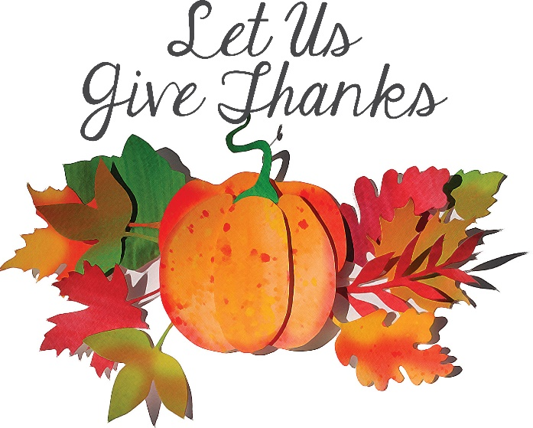

CALL TO WORSHIP
adapted from The Church in Canada

LEADER: In deep gratitude we come to worship God.
PEOPLE: We recognize God as the source of all things.
LEADER: All gifts come from the Spirit of God:
PEOPLE: love, peace, joy, patience, kindness, gentleness are all of God.
LEADER: We come with grateful hearts, not for things, but for who God is.
PEOPLE: We gather to show our gratitude in song and prayer.

HYMN Now Thank We All Our God
#102
Now thank we all our God,
with heart and hands and voices,
who wondrous things has done,
in whom this world rejoices;
who from our mothers’ arms
has blessed us on our way
with countless gifts of love,
and still is ours today.

O may this bounteous God
through all our life be near us,
with ever joyful hearts
and blessed peace to cheer us;
and keep us still in grace,
and guide us when perplexed;
and free us from all ills,
in this world and the next.

All praise and thanks to God
the Father now be given;
the Son, and him who reigns
with them in highest heaven;
the one eternal God,
whom earth and heaven adore;
for thus it was, is now,
and shall be evermore.
Translator: Catherine Winkworth (1858)
Author: Martin Rinkart (1636)
Composer: Johann Crüger (1647)

SCRIPTURE Psalm 126 NRSV
¹ When the Lord restored the fortunes of Zion,
we were like those who dream.
² Then our mouth was filled with laughter,
and our tongue with shouts of joy;
then it was said among the nations,
“The Lord has done great things for them.”
³ The Lord has done great things for us,
and we rejoiced.

⁴ Restore our fortunes, O Lord,
like the watercourses in the Negeb.
⁵ May those who sow in tears
reap with shouts of joy.
⁶ Those who go out weeping,
bearing the seed for sowing,
shall come home with shouts of joy,
carrying their sheaves.

The Word of God for the People of God.
Thanks be to God.

AFFIRMATION OF FAITH The Nicene Creed
We believe in one God,
the Father, the Almighty,
maker of heaven and earth,
of all that is, seen and unseen.

We believe in one Lord, Jesus Christ,
the only Son of God,
eternally begotten of the Father,
God from God, Light from Light,
true God from true God,
begotten, not made,
of one Being with the Father;
through him all things were made.
For us and for our salvation
he came down from heaven,
was incarnate of the Holy Spirit and the Virgin Mary
and became truly human.
For our sake he was crucified under Pontius Pilate;
he suffered death and was buried.
On the third day he rose again
in accordance with the Scriptures;
he ascended into heaven
and is seated at the right hand of the Father.
He will come again in glory
to judge the living and the dead,
and his kingdom will have no end.

We believe in the Holy Spirit, the Lord, the giver of life,
who proceeds from the Father and the Son,
who with the Father and the Son
is worshiped and glorified,
who has spoken through the prophets.
We believe in one holy catholic* and apostolic church.
We acknowledge one baptism
for the forgiveness of sins.
We look for the resurrection of the dead,
and the life of the world to come. Amen.
*universal
The United Methodist Hymnal #880

HYMN Make Me a Servant
#2176, Faith We Sing
Make me a servant
Humble and meek
Lord let me lift up
Those who are weak
And may the prayer
Of my heart always be
Make me a servant
Make me a servant
Make me a servant today
Words & Music: Kelly Willard
© 1982 Willing Heart Music, adm by Maranatha!Music c/o The Copyright Co

FROM THE HEART CAMPAIGN COMMITMENT UPDATE

PRAYER OF THE PEOPLE
written by Rev. Karla Miller

We sing a song of thanksgiving today, dear God.

We pause in the midst of all that is unholy, unthinkable, and undeniable, to look within, and offer our gratitude for a day that has dawned anew, and for the breath that gives us life.

We rejoice that we have voice and head and heart
so that we can love one another, love You, and love all of your people.

We celebrate the abundance in our lives, and that we can share it with the world. In jubilance and grace,
we offer ourselves and all that we are and have
to be your justice and peace

Hear the prayers of your people in the silence of our hearts…

Hear us together as we pray the words Christ taught saying…Our Father, who art in heaven, hallowed be thy name. Thy kingdom come, thy will be done, on earth as it is in heaven. Give us this day our daily bread, and forgive us our trespasses, as we forgive those who trespass against us. And lead us not into temptation, but deliver us from evil. For thine is the kingdom, and the power, and the glory forever. Amen.

HYMN Make Me a Servant
#2176, Faith We Sing
Make me a servant
Humble and meek
Lord let me lift up
Those who are weak
And may the prayer
Of my heart always be
Make me a servant
Make me a servant
Make me a servant today
Words & Music: Kelly Willard
© 1982 Willing Heart Music, adm by Maranatha!Music c/o The Copyright Co

OFFERING

SCRIPTURE Matthew 6:25-33 NRSV
²⁵ “Therefore I tell you, do not worry about your life, what you will eat or what you will drink, or about your body, what you will wear. Is not life more than food, and the body more than clothing? ²⁶ Look at the birds of the air; they neither sow nor reap nor gather into barns, and yet your heavenly Father feeds them. Are you not of more value than they? ²⁷ And can any of you by worrying add a single hour to your span of life? ²⁸ And why do you worry about clothing? Consider the lilies of the field, how they grow; they neither toil nor spin, ²⁹ yet I tell you, even Solomon in all his glory was not clothed like one of these. ³⁰ But if God so clothes the grass of the field, which is alive today and tomorrow is thrown into the oven, will he not much more clothe you—you of little faith? ³¹ Therefore do not worry, saying, ‘What will we eat?’ or ‘What will we drink?’ or ‘What will we wear?’ ³² For it is the Gentiles who strive for all these things; and indeed your heavenly Father knows that you need all these things. ³³ But strive first for the kingdom of God and his righteousness, and all these things will be given to you as well.

The Word of God for the People of God.
Thanks be to God.

MESSAGE Obeying
Rev. David W. Brown

HYMN We Gather Together
#131
We gather together
to ask the Lord’s blessing;
he chastens and hastens
his will to make known.
The wicked oppressing
now cease from distressing.
Sing praises to his name;
he forgets not his own.

Beside us to guide us,
our God with us joining,
ordaining, maintaining
his kingdom divine;
so from the beginning
the fight we were winning;
thou, Lord, wast at our side,
all glory be thine!

We all do extol thee,
thou leader triumphant,
and pray that thou still
our defender wilt be.
Let thy congregation
escape tribulation;
thy name be ever praised!
O Lord, make us free!
Text Translation: Theodore Baker (1894)
Music: Edward Kremser (1877)

BENEDICTION
by the Rev. Thomas L. Weitzel

May the Lord of all creation
shower his blessings and favor upon you.

May the Lord of the harvest
grace your Thanksgiving table with his presence
and fill your loved ones with peace.

May the Lord of salvation
guide you all your days
until you come into the joys of His eternal kingdom.

And may almighty God, Father, Son and Holy Spirit,
bless you now and forever. Amen.

Liturgist at 8:20 – Mark Paluta
Liturgist at 9:40 – Jane Florer

The flowers in the Sanctuary are given by Marge Freshley in memory of her husband, Rev. Wendell Freshley.

Gather for coffee and treats in the Atrium following the 9:40 service!

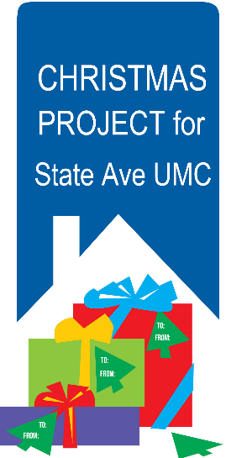
Annual Christmas Project for State Avenue UMC
ONLINE SIGN-UP @ https://bit.ly/2ZHYsTR
Giving to State Avenue UMC in Lower Price Hill this year (like last year) has three opportunities: donate a Christmas Meal kit, donate $15 Kroger cards, or Adopt-a-Kid.

Christmas Meal: Fill a bag with the non-perishable items listed. 26 bags needed. 10 still needed.
Instant Stuffing - TWO 6 oz boxes Instant Mashed Potatoes - 8 oz box
Canned Green Beans - 29 oz can Canned Corn - 29 oz can
Gravy Mix - 1 oz packet or jar Canned Cranberry Sauce - 15 oz can
Canned Sweet Potatoes - 30 oz can Nonperishable Dessert Kits (ex. cake mixes with icing, brownies, cookie mix)
Optional Item: Add a note to the family – include a note or a card with a positive Christmas message.

Kroger Cards: 26 needed. 3 still needed.
$15 Kroger cards that will be used to purchase turkeys. Drop them off at the office or place in the offering.

Adopt-a-Kid: 20 still available.
There are 51 kids from the State Avenue community in need of Christmas gifts. Name, grade and gift suggestions are available to assist with your shopping. Select a child and shop for one of the suggested gifts. Return the item UNWRAPPED and labeled with the child’s name found on the sign-up form. Suggested price point for gifts is $25.

Donations of meal kits, gift cards or gifts are due by Wednesday, Dec. 1. Drop off at the church office or in the Atrium.

Fillmore Brass Band  Wednesday, December 8  in the Sanctuary  a free will offering will be taken  Canterbury Brass  Sunday, December 19  during 9:40am worship  in the Sanctuary | 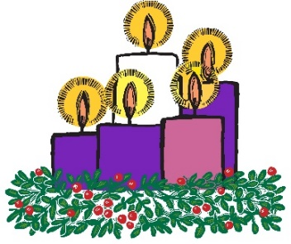  Advent Candle Lighting  We are looking for couples / families / individuals to do a small reading and light the Advent candles during worship.  11/28, 12/5, 12/12, 12/19  @ 8:20am and 9:40am  12/24 @ 5:00, 9:00  https://bit.ly/3GvVdzF | Poinsettias will decorate the Sanctuary starting in mid-Advent. You may purchase a plant in honor of or in memory of loved ones. $20 per plant. You may take your poinsettias home with you on the night of Christmas Eve.  Online order form: https://bit.ly/2Iauekb  Or use the back of your Connect Card (check box #1 for “in honor of” or #2 for “in memory of” and write the person’s name in the comment section), include your payment = $20 per plant, and drop it in the offering or mail to the church office by Sunday, December 12 (attn: Joy, 5125 Drake Rd, 45243).
The Voices of Christmas
A Daily Devotional and Sermon Series for Advent
Are you ready yet? Advent is a time to get ready to celebrate the birth of Christ. While many of us look forward to the activities of Christmas – from caroling to decorating Christmas trees and finding the perfect gift for someone special – the best gift we can give to God and ourselves is to take time each day to focus on what this season is all about.
Healing and Hope Opportunity and Love
Peace Experience and Joy

These themes of HOPE are explored through the unique journeys of six prominent characters in the Christmas story. On the first day of each week you will be introduced to the theme and scripture of the week. On days two through six, explore the theme through the lenses of the characters and their voices, then offering reflective questions. On the seventh day of each week, you will find a summary of the week, as well as additional questions for your personal reflection or processing in your small group.

Books are available in the Atrium for $17. Series will run November 28-December 19 in the 8:20 and 9:40 services.

